­

Amazon Web Services

**Virtual Private Cloud**

# Virtual Private Cloud - VPC

* A virtual private cloud (VPC) is a virtual network dedicated to your AWS account.
* It is logically isolated from other virtual networks in the AWS Cloud. You can launch your AWS resources, such as Amazon EC2 instances, into your VPC.
* There are no additional charges for creating and using an Amazon Virtual Private Cloud (VPC) itself.

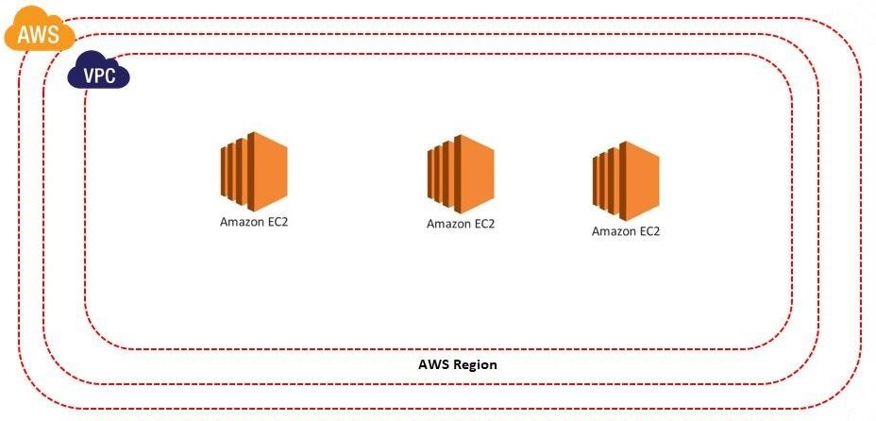

# VPC - Benefits

* **Easy to use and setup:** With the help of the AWS Management Console, one can easily and quickly set up AWS VPC.
* It also helps you to focus only on creating the application as the process such as **Subnets**, **IP ranges**, **route tables**, and **security groups** are automatically created.
* **Security:** To enable inbound and outbound filtering at the instance level and subnet level VPC provides advanced security features.
* **Scalability and Reliability:** AWS VPC provides a facility of instant scalability so that you can instantly scale your resources up or down, and select Amazon EC2 instance types and sizes that are right for your applications.
* It also helps to save the extra cost as there are no upfront costs.

# VPC - Features

* VPC allows the user to select IP address ranges, create subnets, and configure route tables, network gateways, and security settings.
* VPC allows VPC Peering connections with other VPC within the same or different AWS accounts.
* It provides a feature of security such that the data stored in Amazon S3 can only be accessed from within your Amazon VPC.
* We can resize the VPC.
* Max VPC is 5 Per Region. We can increase this limit so that you can have 100s of VPCs per Region.
* We can create 200 Subnets in one VPC & 1000 Subnets in one region

# VPC - Sizing

* VPC needs a set of IP addresses in the form of a Classless Inter-Domain Routing (CIDR) block.

**For example**: the CIDR 172.16.0.0/16 includes all addresses from 172.16.0.0 to 172.16.255.255 — a total of 65,536 addresses. 16 is the netmask.

* As IPV4 is 32 bit so /16 means , 32-16=16 and so 2^16= 65,536 IP addresses
* Similarly for /28 means, 32-28= 4 and so 2^4=16 IP addresses.
* Block sizes must be between a /16 netmask and /28 netmask.
* Minimum Size is /28 (16 IP Address)
* Maximum Size is /16 (65536 IP Address)
* To More about IP Address CIDR: https://www.ipaddressguide.com/cidr
* VPC Quotas: https://docs.aws.amazon.com/vpc/latest/userguide/amazon-vpc-limits.html

# VPC

* Search VPC
* Click on Create VPC
* Enter the Name of the VPC
* Enter IPV4 CIDR
* Select tenancy as default.
* Click on Create VPC